Computing regression parameters (gradient descent example)

The data
Consider the following 5 point synthetic data set:
X Y
0 1
1 3
2 7
3 13
4 21
Which is plotted below:
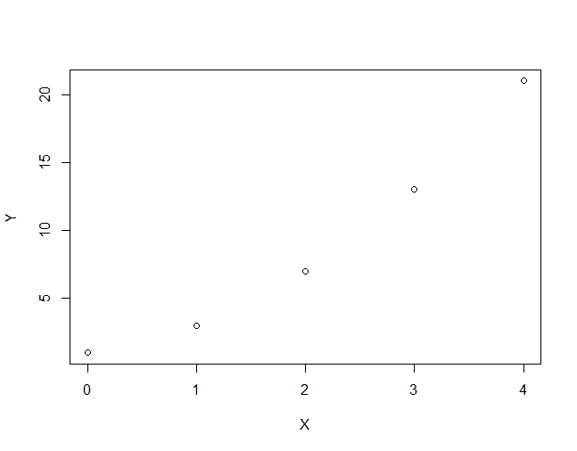

What we need
Now that we’ve computed the regression line using a closed form solution let’s do it again but with gradient descent.
Recall that:
- The derivative of the cost for the intercept is the sum of the errors
- The derivative of the cost for the slope is the sum of the product of the errors and the input
We will need a starting value for the slope and intercept, a step_size and a tolerance
- initial_intercept = 0
- initial_slope = 0
- step_size = 0.05
- tolerance = 0.01

The algorithm
In each step of the gradient descent we will do the following:
1. Compute the predicted values given the current slope and intercept
2. Compute the prediction errors (prediction - Y)
3. Update the intercept:
- compute the derivative: sum(errors)
- compute the adjustment as step_size times the derivative
- decrease the intercept by the adjustment
4. Update the slope:
- compute the derivative: sum(errors*input)
- compute the adjustment as step_size times the derivative
- decrease the slope by the adjustment
5. Compute the magnitude of the gradient
6. Check for convergence

The algorithm in action
First step:
Intercept = 0
Slope = 0
1. predictions = [0, 0, 0, 0, 0]
2. errors = [-1, -3, -7, -13, -21]
3. update Intercept
- sum([-1, -3, -7, -13, -21]) = -45
- adjustment = 0.05 * 45 = -2.25
- new_intercept = 0 - -2.25 = 2.25
4. update Slope
- sum([0, 1, 2, 3, 4] * [-1, -3, -7, -13, -21]) = -140
- adjustment = 0.05 * 45 = -7
- new_slope = 0 - -7 = 7
5. magnitude = sqrt(( -45)^2 + (-140)^2) = 147.05
6. magnitude > tolerance: not converged
Second step:
Intercept = 2.25
Slope = 7
1. predictions = [2.25, 9.25, 16.25, 23.25, 30.25]
2. errors = [1.25, 6.35, 9.25, 10.25, 9.25]
3. update Intercept
- sum([1.25, 6.35, 9.25, 10.25, 9.25]) = 36.25
- adjustment = 0.05 * 36.25 = 1.8125
- new_intercept = 2.25-1.8125 = 0.4375
4. update Slope
- sum([0, 1, 2, 3, 4] * [1.25, 6.35, 9.25, 10.25, 9.25]) = 92.5
- adjustment = 0.05 * 92.5 = 4.625
- new_slope = 7 - 4.625 = 2.375
5. magnitude = sqrt((36.25)^2 + (92.5)^2) = 99.35
6. magnitude > tolerance: not converged
Third step:
Intercept = 0.4375
Slope = 2.375
1. predictions = [0.4375, 2.8125, 5.1875, 7.5625, 9.9375]
2. errors = [-0.5625, -0.1875, -1.8125, -5.4375, -11.0625]
3. update Intercept
- sum([-0.5625, -0.1875, -1.8125, -5.4375, -11.0625]) = -19.0625
- adjustment = 0.05 * = -0.953125
- new_intercept = 0.4375 - -0.953125 = 1.390625
4. update Slope
- sum( [0, 1, 2, 3, 4] * [-0.5625, -0.1875, -1.8125, -5.4375, -11.0625]) = -64.375
- adjustment = 0.05 * -64.375= -3.21875
- new_slope = 2.375 --3.21875 = 5.59375
5. magnitude = sqrt(( -19.0625)^2 + (-64.375)^2) = 67.13806
6. magnitude > tolerance: not converged
Let’s skip forward a few steps… after the 77th step we have gradient magnitude 0.0107.
78th Step:
Intercept = -0.9937
Slope = 4.9978
1. predictions = [-0.99374, 4.00406, 9.00187, 13.99967, 18.99748]
2. errors = [-1.99374, 1.00406, 2.00187, 0.99967, -2.00252]
3. update Intercept
- sum([-1.99374, 1.00406, 2.00187, 0.99967, -2.00252]) = 0.009341224
- adjustment = 0.05 * 0.009341224 = 0.0004670612
- new_intercept = -0.9937 - 0.0004670612 = -0.994207
4. update Slope
- sum([0, 1, 2, 3, 4] * [-1.99374, 1.00406, 2.00187, 0.99967, -2.00252]) = -0.0032767
- adjustment = 0.05 *-0.0032767 = -0.00016383
- new_slope = 4.9978 --0.00016383 = 4.9979
5. magnitude = sqrt[()^2 + ()^2] = 0.0098992
6. magnitude < tolerance: converged!
Final slope: -0.994
Final Intercept: 4.998
If you continue you will get to (-1, 5) but at this point the change in RSS (our cost) is negligible.

Visualizing the steps:
After the first step we have this line:
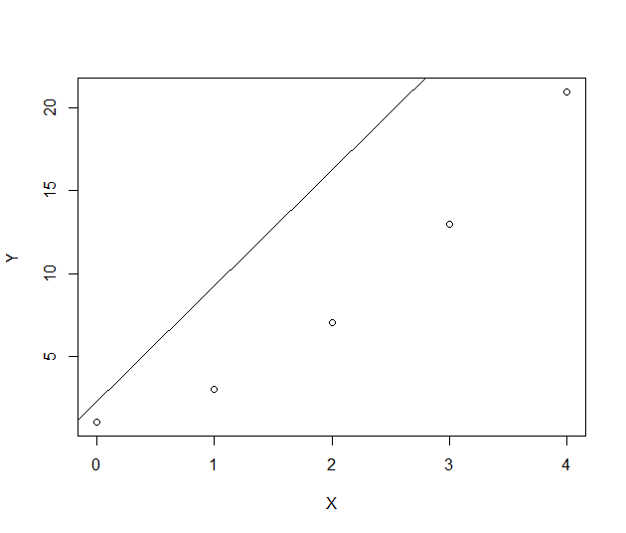
After the second step we have this line:
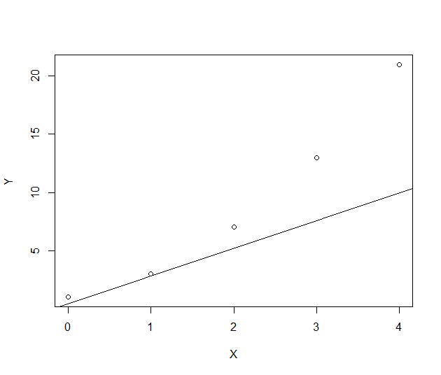
After the third step we have this line:
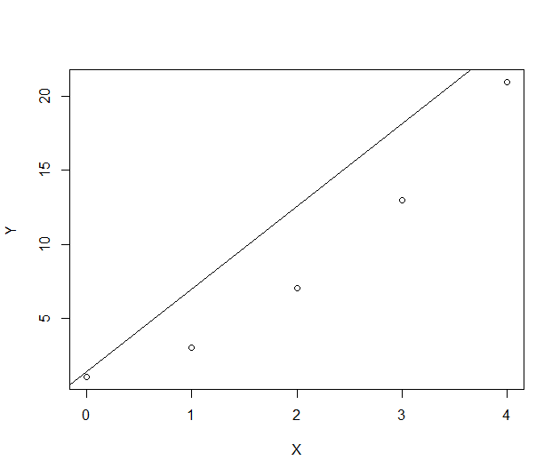
And after the final step we have this line:
